Title - Shop Bridge

Description -

To create API for Products used by the Admin and perform operations like -

Adding New Items

Get All Items

Update Items

Delete Items

Technologies Used -

.Net Core , Entity Framework , SQL Server , XUnit , C# Langauge

Tracking Details -

A] Data Store Design -

Created Database - Product

Created Table - Products

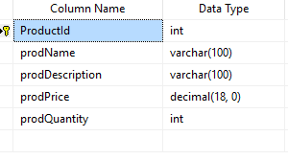

Estimated time - 30 mins

B] API and Service Logic -

Created Controller which consisted of following API -

GetProducts()

GetProducts(int id)

PostProducts()

PutProducts()

DeleteProducts()

Created Context file in order access DB and then used Entity Framework

References -

**Install-Package Microsoft.EntityFrameworkCore.Tools -Version 3.1.8**

This package helps create database context and model classes from the database.

**Install-Package Microsoft.EntityFrameworkCore.SqlServer -Version 3.1.8**

Database provider allows Entity Framework Core to work with SQL Server.

Estimated time - 60 mins

C] Unit Test Coverage

Added new project and used XUnit test cases to create the test cases for API

Estimated time - 30 mins